INTRODUCTION TO OCCUPATIONAL
HEALTH AND SAFETY
I. Introduction
What is occupational health and safety?
Occupational health and safety is a discipline with a broad scope involving many specialized fields. In its broadest sense, it should aim at:
- the promotion and maintenance of the highest degree of physical, mental and social well-being of workers in all occupations;
- the prevention among workers of adverse effects on health caused by their working conditions;
- the protection of workers in their employment from risks resulting from factors adverse to health;
- the placing and maintenance of workers in an occupational environment adapted to physical and mental needs;
- the adaptation of work to humans.
In other words, occupational health and safety encompasses the social, mental and physical well-being of workers, that is the “whole person”.
Successful occupational health and safety practice requires the collaboration and participation of both employers and workers in health and safety programmes, and involves the consideration of issues relating to occupational medicine, industrial hygiene, toxicology, education, engineering safety, ergonomics, psychology, etc.
Occupational health issues are often given less attention than occupational safety issues because the former are generally more difficult to confront. However, when health is addressed, so is safety, because a healthy workplace is by definition also a safe workplace. The converse, though, may not be true - a so-called safe workplace is not necessarily also a healthy workplace. The important point is that issues of both health and safety must be addressed in every workplace. By and large, the definition of occupational health and safety given above encompasses both health and safety in their broadest contexts.
Poor working conditions affect worker health and safety
- Poor working conditions of any type have the potential to affect a worker's health and safety.
- Unhealthy or unsafe working conditions are not limited to factories — they can be found anywhere, whether the workplace is indoors or outdoors. For many workers, such as agricultural workers or miners, the workplace is “outdoors” and can pose many health and safety hazards.
- Poor working conditions can also affect the environment workers live in, since the working and living environments are the same for many workers. This means that occupational hazards can have harmful effects on workers, their families, and other people in the community, as well as on the physical environment around the workplace. A classic example is the use of pesticides in agricultural work. Workers can be exposed to toxic chemicals in a number of ways when spraying pesticides: they can inhale the chemicals during and after spraying, the chemicals can be absorbed through the skin, and the workers can ingest the chemicals if they eat, drink, or smoke without first washing their hands, or if drinking water has become contaminated with the chemicals. The workers' families can also be exposed in a number of ways: they can inhale the pesticides which may linger in the air, they can drink contaminated water, or they can be exposed to residues which may be on the worker's clothes. Other people in the community can all be exposed in the same ways as well. When the chemicals get absorbed into the soil or leach into groundwater supplies, the adverse effects on the natural environment can be permanent.
Overall, efforts in occupational health and safety must aim to prevent industrial accidents and diseases, and at the same time recognize the connection between worker health and safety, the workplace, and the environment outside the workplace.
Why is occupational health and safety important?
Work plays a central role in people's lives, since most workers spend at least eight hours a day in the workplace, whether it is on a plantation, in an office, factory, etc. Therefore, work environments should be safe and healthy. Yet this is not the case for many workers. Every day workers all over the world are faced with a multitude of health hazards, such as:
- dusts;
- gases;
- noise;
- vibration;
- extreme temperatures.
Unfortunately some employers assume little responsibility for the protection of workers' health and safety. In fact, some employers do not even know that they have the moral and often legal responsibility to protect workers. As a result of the hazards and a lack of attention given to health and safety, work-related accidents and diseases are common in all parts of the world.
Costs of occupational injury/disease
How much does an occupational disease or accident cost? | 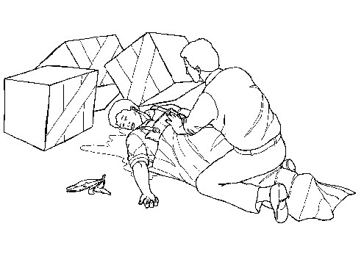
Work-related accidents or diseases are very costly and can have many serious direct and indirect effects on the lives of workers and their families. For workers some of the direct costs of an injury or illness are:
- the pain and suffering of the injury or illness;
- the loss of income;
- the possible loss of a job;
- health-care costs.
It has been estimated that the indirect costs of an accident or illness can be four to ten times greater than the direct costs, or even more. An occupational illness or accident can have so many indirect costs to workers that it is often difficult to measure them. One of the most obvious indirect costs is the human suffering caused to workers' families, which cannot be compensated with money.
The costs to employers of occupational accidents or illnesses are also estimated to be enormous. For a small business, the cost of even one accident can be a financial disaster. For employers, some of the direct costs are:
- payment for work not performed;
- medical and compensation payments;
- repair or replacement of damaged machinery and equipment;
- reduction or a temporary halt in production;
- increased training expenses and administration costs;
- possible reduction in the quality of work;
- negative effect on morale in other workers.
Some of the indirect costs for employers are:
- the injured/ill worker has to be replaced;
- a new worker has to be trained and given time to adjust;
- it takes time before the new worker is producing at the rate of the original worker;
- time must be devoted to obligatory investigations, to the writing of reports and filling out of forms;
- accidents often arouse the concern of fellow workers and influence labour relations in a negative way;
- poor health and safety conditions in the workplace can also result in poor public relations.
Overall, the costs of most work-related accidents or illnesses to workers and their families and to employers are very high.
On a national scale, the estimated costs of occupational accidents and illnesses can be as high as three to four per cent of a country's gross national product. In reality, no one really knows the total costs of work-related accidents or diseases because there are a multitude of indirect costs which are difficult to measure besides the more obvious direct costs.
Health and safety programmes
For all of the reasons given above, it is crucial that employers, workers and unions are committed to health and safety and that:
- workplace hazards are controlled - at the source whenever possible;
- records of any exposure are maintained for many years;
- both workers and employers are informed about health and safety risks in the workplace;
- there is an active and effective health and safety committee that includes both workers and management;
- worker health and safety efforts are ongoing.
Effective workplace health and safety programmes can help to save the lives of workers by reducing hazards and their consequences. Health and safety programmes also have positive effects on both worker morale and productivity, which are important benefits. At the same time, effective programmes can save employers a great deal of money.
II. Extent of the problem worldwide
A. Accidents
In general, health and safety in the workplace has improved in most industrialized countries over the past 20 to 30 years. However, the situation in developing countries is relatively unclear largely because of inadequate accident and disease recognition, record-keeping and reporting mechanisms.
It is estimated that at least 250 million occupational accidents occur every year worldwide. 335,000 of these accidents are fatal (result in death). (Since many countries do not have accurate record-keeping and reporting mechanisms, it can be assumed that the real figures are much higher than this.) The number of fatal accidents is much higher in developing countries than in industrialized ones. This difference is primarily due to better health and safety programmes, improved first-aid and medical facilities in the industrialized countries, and to active participation of workers in the decision-making process on health and safety issues. Some of the industries with the highest risk of accidents worldwide are: mining, agriculture, including forestry and logging, and construction.
Identifying the cause of an accident
In some cases, the cause of an industrial injury is easy to identify. However, very often there is a hidden chain of events behind the accident which led up to the injury. For example, accidents are often indirectly caused by negligence on the part of the employer who may not have provided adequate worker training, or a supplier who gave the wrong information about a product, etc. The consistently high fatal accident rates in developing countries emphasize the need for occupational health and safety education programmes that focus on prevention. It is equally important to promote the development of occupational health services, including the training of doctors to recognize work-related diseases in the early stages.
B. Diseases
Exposure to hazards in the workplace can lead to serious illness. | 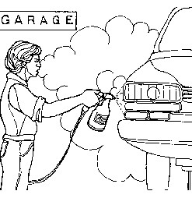 | 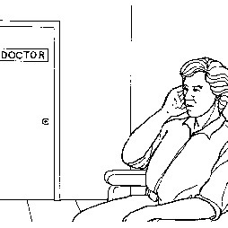
Some occupational diseases have been recognized for many years, and affect workers in different ways depending on the nature of the hazard, the route of exposure, the dose, etc. Some well known occupational diseases include:
- asbestosis (caused by asbestos, which is common in insulation, automobile brake linings, etc.);
- silicosis (caused by silica, which is common in mining, sandblasting, etc.);
- lead poisoning (caused by lead, which is common in battery plants, paint factories, etc.);
- and noise-induced hearing loss (caused by noise, which is common in many workplaces, including airports, and workplaces where noisy machines, such as presses or drills, etc. are used).
There are also a number of potentially crippling health problems that can be associated with poor working conditions, including:
- heart disease;
- musculoskeletal disorders such as permanent back injuries or muscle disorders;
- allergies;
- reproductive problems;
- stress-related disorders.
Many developing countries report only a small number of workers affected by work-related diseases. These numbers look small for a variety of reasons that include:
- inadequate or non-existent reporting mechanisms;
- a lack of occupational health facilities;
- a lack of health care practitioners who are trained to recognize work-related diseases.
Because of these reasons and others, it is fair to assume that in reality, the numbers of workers afflicted with occupational diseases are much higher. In fact, overall, the number of cases and types of occupational diseases are increasing, not decreasing, in both developing and industrialized countries.
Identifying the cause of occupational disease
The cause of work-related diseases is very often difficult to determine. One factor is the latency period (the fact that it may take years before the disease produces an obvious effect on the worker's health). By the time the disease is identified, it may be too late to do anything about it or to find out what hazards the worker was exposed to in the past. Other factors such as changing jobs, or personal behaviours (such as smoking tobacco or drinking alcohol) further increase the difficulty of linking workplace exposures to a disease outcome.
Although more is understood now about some occupational hazards than in the past, every year new chemicals and new technologies are being introduced which present new and often unknown hazards to both workers and the community. These new and unknown hazards present great challenges to workers, employers, educators, and scientists, that is to everyone concerned about workers' health and the effects that hazardous agents have on the environment.
III. The range of hazards
There is an unlimited number of hazards that can be found in almost any workplace. There are obvious unsafe working conditions, such as unguarded machinery, slippery floors or inadequate fire precautions, but there are also a number of categories of insidious hazards (that is, those hazards that are dangerous but which may not be obvious) including:
- chemical hazards, arising from liquids, solids, dusts, fumes, vapours and gases;
- physical hazards, such as noise, vibration, unsatisfactory lighting, radiation and extreme temperatures;
- biological hazards, such as bacteria, viruses, infectious waste and infestations;
- psychological hazards resulting from stress and strain;
- hazards associated with the non-application of ergonomic principles, for example badly designed machinery, mechanical devices and tools used by workers, improper seating and workstation design, or poorly designed work practices.
Most workers are faced with a combination of these hazards at work. For example, it is not difficult to imagine a workplace where you are exposed to chemicals, unguarded and noisy machines, hot temperatures, slippery floors, etc. all at the same time. Think about your own workplace. Are there various hazards there that you can think of?
Hazards are often built into workplace. | 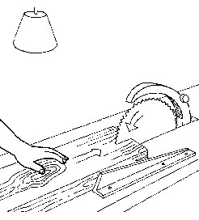
Workers do not create hazards - in many cases the hazards are built into the workplace. The trade union position on occupational health and safety is to ensure that work is made safer by modifying the workplace and any unsafe work processes. This means that the solution is to remove the hazards, not to try to get workers to adapt to unsafe conditions. Requiring workers to wear protective clothing which may not be suited or designed for the climate of your region is an example of forcing workers to try to adapt themselves to unsafe conditions, which is also shifting the responsibility from management to the worker.
It is important for unions to maintain this position because many employers blame workers when there is an accident, claiming that the workers were careless. This attitude implies that work can be made safer if workers change their behaviour or if employers only hire workers who never make mistakes. Everyone makes mistakes — it is human nature, but workers should not pay for mistakes with their lives. Accidents do not stop simply by making workers more safety conscious. Safety awareness may help but it does not remove unsafe work processes or conditions. The most effective accident and disease prevention begins when work processes are still in the design stage, when safe conditions can be built into the work process.
IV. Importance of management commitment
A successful health and safety programme requires strong management commitment and worker participation. | 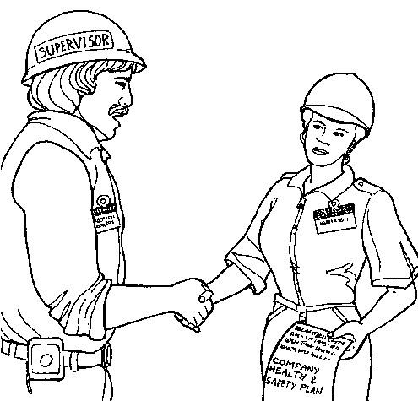
In order to develop a successful health and safety programme, it is essential that there be strong management commitment and strong worker participation in the effort to create and maintain a safe and healthy workplace. An effective management addresses all work-related hazards, not only those covered by government standards.
All levels of management must make health and safety a priority. They must communicate this by going out into the worksite to talk with workers about their concerns and to observe work procedures and equipment. In each workplace, the lines of responsibility from top to bottom need to be clear, and workers should know who is responsible for different health and safety issues.
V. The importance of training
Effective training is a key component of any health and safety programme. | 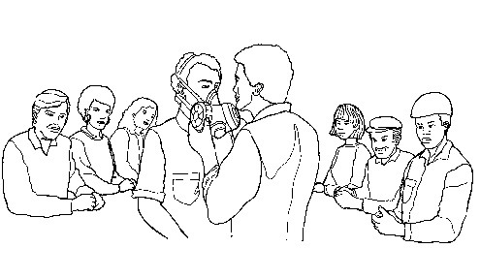
Workers often experience work-related health problems and do not realize that the problems are related to their work, particularly when an occupational disease, for example, is in the early stages. Besides the other more obvious benefits of training, such as skills development, hazard recognition, etc., a comprehensive training programme in each workplace will help workers to:
- Recognize early signs/symptoms of any potential occupational diseases before they become permanent conditions;
- Assess their work environment;
- Insist that management make changes before hazardous conditions can develop.
VI. Role of the health and safety representative
As health and safety representative your role is to work proactively (this means taking action before hazards become a problem) to prevent workers from being exposed to occupational hazards. You can do this by making sure management eliminates hazards or keeps them under control when they cannot be eliminated.
Steps to help you reach your goals are:
1. Be well informed about the various hazards in your workplace and the possible solutions for controlling those hazards.
2. Work together with your union and the employer to identify and control hazards.
3. Although these Modules have been developed for the protection of workers, you may occasionally need to share some of this information with your supervisors and employer in the process of working towards a safe and healthy workplace.
Being a health and safety representative is not always easy, but helping to protect the lives of your fellow workers is worth all the time and effort you put into the job.

